Cross-shelf patterns in zooplankton characteristics in a western boundary current region

OR

Zooplankton characteristics across a western boundary current influenced continental shelf

Hayden T. Schilling1,2, Jason D. Everett2,3, Amandine Schaeffer4, Peter Yates1,2, Mark E. Baird5, Iain M. Suthers1,2

1Sydney Institute of Marine Science, Chowder Bay Road, Mosman, New South Wales, Australia

2Centre for Marine Science & Innovation, University of New South Wales, High Street, Kensington, New South Wales, Australia

3Centre for Applications in Natural Resource Mathematics (CARM), School of Mathematics and Physics, University of Queensland, Brisbane, QLD, Australia

4School of Mathematics and Statistics, University of New South Wales, High Street, Kensington, New South Wales, Australia

5Commonwealth Scientific and Industrial Research Organisation, Castray Esplanade, Battery Point, Tasmania, Australia

Corresponding author: Hayden T. Schilling ([Hayden.Schilling@sims.org.au](mailto:Hayden.Schilling@sims.org.au))

**NOTES:**

**Figures aren’t finalised. Some have minor details to fix, including interpolations**

* Figures 7 & 8 show strong patterns but they are really just repeats of Figures 3 which I think are better because they show the depth and distance from coast at the same time which I think is important. I think we should remove F7 and F8 – thoughts?
* Iain previously asked for a quantitative summary and plot of previous work (section 2.5) which looked at changes in biomass/abundance across continental shelves. I have not included this in this version because it is not finished and I’m unsure of the value of adding this information as it was already included as a table in Marcolin (2013) where they identified it may not be appropriate to compare all the studies.

Abstract

Zooplankton are an important food source for many pelagic ecosystems, yet it is largely unknown how the zooplankton community varies horizontally and vertically across continental shelves, particularly in areas influenced by strong boundary currents. Western boundary currents are known to influence continental shelf waters through a variety of physical mechanisms including bottom water intrusions and coastal upwelling which have the potential to influence the planktonic community. Using an optical plankton counter and CTD mounted on an undulating towed body in waters, this study presents the first high-resolution depth-resolved profiles of the zooplankton community across a continental shelf. We show that zooplankton biomass tends to be highest inshore with a decline in biomass with both increasing distance from shore and depth in the water column. Within uplift influenced zones, the inner shelf zooplankton communities tended to be smaller and more productive, as determined by smaller geometric mean sizes and steeper estimated normalised biomass size spectrum slopes. The patterns observed in this study align with previous research on zooplankton distributions on continental shelves suggesting that globally inner continental shelf regions appear to be more productive and support high biomasses of zooplankton compared to offshore, particularly where uplift may be a common occurrence. This may be a driver of the highly productive fisheries which are often found on continental shelfs.

1 Introduction

Western boundary currents (WBCs) are fast-flowing currents which transport warm salty water from the tropics to the poles. At a broad scale, WBCs flow along continental boundaries generally inhibiting cross-shelf transport due to their strong along-shore flows (Roughan *et al.*, 2011). At a smaller scale, WBCs interact with the continental shelves to generate eddies, fronts and upwelling that can increase transport across the shelf (Malan *et al.*, 2020). By increasing upwelling of cold water on the continental shelf (Schaeffer *et al.*, 2013), WBCs contribute to production through the supply of nutrients normally found in cooler deeper water (Pereira Brandini *et al.*, 2014).

Oceanographic features are key drivers in the distribution of zooplankton (Coyle and Pinchuk, 2002; Skarðhamar *et al.*, 2007). The distribution of zooplankton is the result of a number of factors including physical mechanisms such as transport and retention, biological factors including prey availability and predator abundance as well as behaviour of the zooplankton (Huntley *et al.*, 2000). A combination of nutrients from upwelling and terrestrial inputs are thought to be the cause of generally higher biomasses of zooplankton on the continental shelf compared with adjacent oceanic regions. Higher zooplankton biomass on the continental shelf has been observed in the southeast Atlantic (Marcolin *et al.*, 2013), northeast Atlantic (Sourisseau and Carlotti, 2006; Irigoien *et al.*, 2009; Vandromme *et al.*, 2014) and southwest Atlantic (Pereira Brandini *et al.*, 2014). While this increase in biomass in nearshore environments is thought to be enhanced by increased nutrients from terrestrial discharge, the influence of terrestrial inputs varies between regions and some regions such as eastern Australia are known to have relatively small terrestrial influences when compared to other sources of nutrients such as upwelling (Apte *et al.*, 1998).

Despite exploration of spatial patterns in zooplankton on continental shelves, few studies have examined patterns of zooplankton with depth on continental shelves. Off New York, during late summer it was observed that vertical zooplankton abundance was strongly influenced by water mass with distinct zooplankton communities separated by a strong thermocline (Turner and Dagg, 1983). This is contrasted by a winter study on the Abrolhos Bank where, on the shelf, copepod abundance peaked near the surface (20 – 40m) and decreased with depth (Marcolin *et al.*, 2015). Recently it has been suggested that light availability and predation by fish are significant drivers of zooplankton depth distributions (Aarflot *et al.*, 2019).

Zooplankton are an important trophic link (Libralato *et al.*, 2006). As prey for zooplanktivorous fish, zooplankton transfer energy up the food web to higher trophic levels (Marquis *et al.*, 2011; Champion *et al.*, 2015) with zooplankton supporting up to 53 % of fish biomass on temperate coastal reefs (Truong *et al.*, 2017). Predator-prey interactions involving zooplankton are usually driven by body size (Barnes *et al.*, 2010), and by focusing on the size distribution of the zooplankton community, complex species-specific dynamics can be simplified. One method of analysing community size structure is the Normalized Biomass Size Spectrum (NBSS; Kerr and Dickie, 2001). Using a linear fit of normalized biomasses in logarithmically equal size bins, the structure of the zooplankton community is quantified, with a general overall slope of -1 observed in the open sea (Sheldon *et al.*, 1972; Baird *et al.*, 2008). A steeper slope with a large fraction of small particles generally infers and higher production and predation while a shallow slope often represents lower predation and less ‘top-down’ pressure (Moore and Suthers, 2006; Blanchard *et al.*, 2017). While widely used, the linear fit for the NBSS is sometimes bias by size classes containing no particles due to small sample sizes and it has been shown that the shape parameter *c* of a Pareto distribution is highly correlated to the NBSS slope and provides a more robust estimate of the NBSS slope for smaller samples (Vidondo *et al.*, 1997; Suthers *et al.*, 2006).

In the southeast Atlantic, the zooplankton community on the continental shelf had higher biomass and a steeper NBSS slope compared to the offshore oceanic stations which were typically more vertically stratified (Marcolin *et al.*, 2013). This is similar to the northeast Atlantic where high zooplankton biomasses and steeper NBSS slopes were found in some but not all inshore regions (Sourisseau and Carlotti, 2006; Irigoien *et al.*, 2009; Vandromme *et al.*, 2014).

Smaller scale processes such as island wakes have also produce variations in zooplankton community structure as they create areas with potentially more retention and production (Rissik *et al.*, 1997). In the tropical Coral Sea, it was shown that zooplankton communities have a both higher abundances and a steeper NBSS slope in the wake of islands compared to in the free stream with the difference attributed to both increased production and predation by fish removing larger zooplankton (Rissik *et al.*, 1997; Suthers *et al.*, 2006).

Despite the previous research on cross-shelf distributions of zooplankton and targeted studies on smaller scale effects such as island wakes, there remains little knowledge about how WBCs effect zooplankton communities on temperate continental shelfs, particularly in terms of the depth structure. This lack of knowledge is particularly prevalent in temperate eastern Australia where there has been no research into cross-shelf patterns of zooplankton and terrestrial inputs are known to be small compared to potential nutrient inputs from upwelling.

We aim to describe cross-shelf and depth stratified patterns in the zooplankton community by using a case study of four depth stratified, cross-shelf transects of zooplankton on the eastern continental shelf of Australia to:

1. Identify latitudinal differences in zooplankton distribution across a continental shelf in a WBC region, and
2. Identify potential drivers of the observed patterns in zooplankton biomass, size and productivity and propose a general concept of zooplankton distribution on a WBC influenced continental shelf.

2. Materials and Methods

*2.1 East Australian Current*

Flowing poleward from the Coral Sea, the East Australian Current (EAC) is a baroclinic jet which forms between 10 and 20 °S when the South Equatorial Current diverges against the Australian coast. The southward flowing component, the EAC, flows at approximately 0.5 – 1 m s-1 along the continental shelf (Archer *et al.*, 2017) until the majority of the EAC separates from the coast at approximately 30 – 32 °S and continues to flow eastward as the EAC eastern extension (Cetina-Heredia *et al.*, 2014; Oke *et al.*, 2019). The remaining portion of the EAC continues to flow south along the coast as part of the EAC southern extension generating a large eddy field (Everett *et al.*, 2012). Along the continental shelf, particularly where the continental shelf narrows, the EAC has significant impact on shelf circulation (Schaeffer and Roughan, 2015). Current driven bottom friction leads to Ekman transport in the bottom boundary layer, moving cooler denser water up the slope, resulting in uplift of isotherms and upwelling (Schaeffer *et al.*, 2014). These intrusion events have been shown to bring nutrient rich water into the euphotic zone, increasing nitrate (Rossi *et al.*, 2014) and chlorophyll *a* concentration (Everett *et al.*, 2014), and controlling vertical phytoplankton abundance, composition and distribution (Armbrecht *et al.*, 2014, 2015).

*2.2 Voyage details*

From 2nd – 13th September 2004, a research voyage on the on the RV Southern Surveyor was undertaken from Sydney, Australia (33.82° S, 151.29° E) to Brisbane, Australia (27.36° S, 153.17° E). During this period, the EAC was flowing southward along the coast until approximately 31 °S where it separated from the mainland and continued flowing to the east. This separation resulted in the formation of a large anti-cyclonic warm-core eddy forming off the coast at approximately 33 °S, 155 °E (Figure 1).

*2.3 Sampling*

Four constant latitude transects were sampled roughly perpendicular to the north NSW coast over a seven-day period (6th – 12th September; Table 1) using a towed device called the Bunyip (a highly modified SeaSoar). The Bunyip was towed from inshore to offshore and undulated between 10 and 120 m depth. Mounted on the Bunyip was a XXCTDXX and an Optical Plankton Counter (OPC; Herman 1992) to measure temperature, salinity and the size distribution of particulate matter. The ship was also equipped with an R. D. Instruments VM-150 ADCP which continuously monitored the velocity of water beneath the vessel. Alongshore and cross-shelf velocity of currents was calculated by rotating the U and V vectors to account for the angle of the coastline at each location (Table 1). The shelf sampling was interrupted on the 8-10th September to undertake a wake study around North Solitary Island (29°55'S, 153°23'E) which will be reported elsewhere.

*2.4 Zooplankton Data*

The OPC was a Focal Technologies Corporation Model OPC-2T with a sampling aperture of 2 x 10 cm. The OPC records equivalent spherical diameters (ESD) of particles that pass through the instrument in 0.5 s intervals. The particle sizes were recorded digitally using 4096 size bins, corresponding within the operating range of the instrument to bins with a width varying between 5 and 15 µm.

The volume of flow through the sample region was based on distance measured over a 6 s interval. It has been previously shown that a 6 s interval provides the best possible vertical and horizontal resolution (≈ 6 m vertically) of the size distribution in the Tasman Sea region, near the current study area (Baird *et al.*, 2008). To quantify the zooplankton community, several metrics were calculated for each interval of our transects. These included total biomass (mg m-3), geometric mean size (GSM; µm ESD) and the shape parameter *c* of the Pareto distribution of the particles which is an estimate of the NBSS slope. The Pareto distribution has been successfully used in this region previously to spatially resolve the size distribution of particles (Baird *et al.*, 2008).

The Pareto distribution has a probability density function (*pdf*) defined as:

$$pdf(s)=ck^{c}s^{-(c+1)}$$

where *s* is the size of the particle, and *c* and *k* are the distribution’s shape and scale parameters, respectively (Vidondo *et al.*, 1997).

*2.5 Other Environmental Data*

To investigate environment conditions leading up to and during the sampling of transects on the east Australian continental shelf, MODIS-Aqua Level 3 ocean-colour data (chlorophyll-a) and Sea Surface Temperature were obtained from the Integrated Marine Observing System (IMOS) Data Portal (<http://imos.aodn.org.au/imos/>) at 1 km resolution. Chlorophyll-a was derived using the OC3 algorithm. MODIS data were retrieved for 5x5 pixels (~25 km2) surrounding the western and eastern edges of each transect, for the month prior to the day of sampling. Sea surface temperature was obtained from L3S AVHRR daily night product from the same portal, displayed as a map for the region (resolution of 0.02o). Surface geostrophic currents were derived from gridded sea level gradients from satellite altimetry, also taking into account sea level gauges to improve the estimate in coastal area (resolution of 0.2o)

To investigate the seasonal variation of the EAC strength in the region of our transects, 10 years (2004 – 2013) of surface geostrophic velocity from satellite altimetry were obtained from the IMOS Data Portal (<http://imos.aodn.org.au/imos/>) for each of our transects. Alongshore and cross-shelf velocity of currents was calculated by rotating the U and V vectors to account for the angle of the coastline at each location (Table 1). The monthly mean (and SD) alongshore velocity was calculated for the 10-year period by averaging the daily velocities. The assumption being that faster alongshore velocity would be due to increased influence of the EAC. Bathymetry data was sourced from GEBCO (GEBCO Bathymetric Compilation Group, 2019).

Wind data was extracted from Coffs Harbour meteorological station from the Bureau of Meteorology (-30.311, 153.118,) located close to shore at 5 m height. The hourly wind stress was calculated following Wood *et al*. (2016).

*2.6 A global context* **(Still to finish)**

To place our east Australian transects in a global context and identify general trends in zooplankton communities on continental shelves, we examined previous studies which investigated spatial changes in zooplankton communities over continental shelf regions. We identified X studies which investigated changes in zooplankton communities over continental shelves and if possible from each study we extracted inshore and offshore values for biomass, abundance and the NBSS slope. From each study we extracted a maximum of one inshore-offshore per 1 latitude of sampling with the data restricted to spring/early summer to reduce seasonal influences as this is when the majority of studies were undertaken.

Specific details on quantifying needed

3 Results

*3.1 Regional Oceanography*

The three northern most sites (north of 30°S) all crossed from cool inshore waters into warm (>21 °C) EAC water (Figure 1). This is contrasted by the southern transect (Diamond Head 31.75°S) transect which was located south of the separation zone in cooler (<19.5 °C) waters and did not cross into EAC waters. All transects showed low chlorophyll levels (<1.4 mg m-3) which was representative of the previous month of low chlorophyll-a at these locations (Figure S1). There were negligible effects of wind on circulation in the 3 days prior to the transects (Figure SX) with most of the wind coming from a southerly direction.

*3.2 Cape Byron (28.6°S)*

The northernmost transect at Cape Byron (28.6°S) was dominated by the EAC which had a strong alongshore flow (1.50 m s-1) centred over the 200 m isobath (27.6 km offshore). Most of the continental shelf was flooded by warm EAC water (Figure 2). The shipboard ADCP showed slight onshore movement of the EAC which increased offshore and with depth, peaking between 100 and 200m depth (up to 0.26 m s-1, Figure SX). The strong EAC flow resulted in strong current-driven uplift of the isotherms inshore of the EAC with the 21 °C isotherm rising to the surface from 70 m depth over 5 km and the 20 °C isotherm rising to the surface from 100 m depth over 15 km.

A decline in zooplankton biomass was observed from both inshore to offshore and from the surface to depth with the highest biomass (~750 mg m-3) observed at the surface ~20 km from the coastline, just inshore of the 21 °C isotherm. This 21 °C isotherm appears to be a strong delineator of both zooplankton biomass and the size distribution of the zooplankton community. The EAC waters, warmer than 21°C and > 1.2 m s-1 southward velocity, were characterised by low zooplankton biomass with a GMS of ≈450 µm ESD with pareto *c* shape parameter estimate (≈NBSS slope) of between -1 and -1.3. The cooler water immediately inshore of the 21°C isotherm had a high zooplankton biomass, shallower *c* (-0.9) with large particles (GMS 500 µm ESD). Further inshore again (15 -17 km from the coastline), in water < 20 °C, biomass remained high, but the particles were smaller (GMS ≈430 µm ESD), resulting in a steeper *c* (≈-1.25).

*3.3 Evans Head (29°S)*

The transect slightly further south at Evans Head (29°S) did not go as far offshore as the other transects but was still largely influenced by the EAC which had a strong along-shore flow (1.47 m s-1) centred 36.1 km from the coast, near the edge of the continental shelf (220 m seabed depth; Figure 2). The EAC showed offshore movement (0.27 m s-1) which increased with distance offshore. There was strong current driven uplift of the isotherms inshore of the EAC with the 21 °C isotherm rising to the surface from 70 m depth over 6 km and the 20 °C isotherm rising to the surface from 100 m depth over 15 km similar to the northern Cape Byron site (28.6° S).

The zooplankton community was strongly related to the water masses along the transect with strong relationships observed with temperature. Around the front between the continental shelf water (< 21°C) and the warm (> 21°C) EAC water the zooplankton community showed a similar GMS of ~450 µm ESD to that observed at the northern Cape Byron transect but had a higher biomass and shallower pareto distribution shape parameter *c* (~-1; Figures 3, 4 & 5). In the cool inshore waters < 20°C, there continued to be high zooplankton biomass, but the community had shifted towards smaller particles which resulted in a steeper *c* (< -1.3; Figure 5).

*3.4 North Solitary (30°S)*

The transect at North Solitary (30°S) showed the strongest evidence of current driven uplift of any of the transects with the 21 °C isotherm rising to the surface from 70 m depth over 3 km and the 20 °C isotherm rising to the surface from 100 m depth over 10 km (Figure 3). The offshore portion of the transect continued to be dominated by the EAC which had a strong alongshore flow (1.59 m s-1) centred 37.7 km offshore (310 m bathymetry; Figure 2). The EAC had slight onshore movement, in offshore waters 100-150m below the surface (0.15 m s-1; Figure SX).

The biomass of the zooplankton community generally decreased with distance offshore and with depth. The EAC, particularly further offshore, contained low zooplankton biomass with a shallow pareto distribution shape parameter *c* (-0.9) and GMS of ~450 µm. The 20 °C isotherm was a strong boundary for zooplankton communities with zooplankton in water < 20 °C having relatively low biomass and a much smaller GMS (~400µm ESD) resulting in a steeper *c* (< -1.3). This was particularly evident where the 20°C isotherm reach the surface ~24 km from the coastline (Figures 4 & 5).

*3.5 Diamond Head (31.75°S)*

The most southern transect located at Diamond Head (31.75°S) was not influenced by the EAC which had separated from the coast to the north and as such was characterised by a more homogeneous water mass. Within the transect the, alongshore velocities are low (< 0.43 m s-1, Figure 2) with low onshore movement of water (0.11 m s-1) in the surface waters and offshore movement (0.27 m s-1) in the deeper waters (Figure SX). There was minor uplift of the temperature isotherms with all isotherms rising approximately 20 – 40 m as they came onto the continental shelf. This uplift is likely caused by the separation of the EAC from the coast to the north, generating uplift through the creation of eddies near Diamond Head rather than current driven uplift observed at the northern EAC influenced sites (Roughan and Middleton, 2002; Schaeffer and Roughan, 2015).

Reflecting the more homogenous water mass along this transect, the zooplankton community was not clearly related to water masses and are more likely du to physical location. Inshore, the zooplankton community was charactered by larger individuals (GMS ~500 µm ESD) and had higher overall biomass which declined steadily with distance offshore and with depth (Figures 3 & 4). The pareto distribution shape parameter *c* of the community was shallow and steady over the whole transect (~-0.9; Figure 5).

*3.6 Overall Patterns and Seasonal Changes in the EAC*

Satellite altimetry showed throughout the year alongshore velocity varies at our transects by approximately 0.25 m s-1 with the more northern sites having the fastest overall flow (Figure 6). The velocity at all sites slows between April and August before peaking in peaking during September or October and remaining high until March corresponding to austral spring and summer.

Both the EAC-influenced transects (three northern ones) and the transect south of the EAC (Diamond Head) showed that generally higher zooplankton biomasses were observed in continental shelf waters with declines offshore and with depth (Figures 7 & 8) although peaks in biomass were observed at the front between the continental shelf waters and EAC waters (21° C isotherm). The transect at Evans Head did not show a noticeable decline in biomass with distance from the coast but this transect did not extend past the edge of the continental shelf where the declines were seen in the other 3 transects.

Three distinct patterns in GMS were evident in our 4 transects. Cape Byron and Evans Head showed evidence of larger GMS around the front between the warm EAC and cooler inner shelf water (around the 21°C isotherm). North Solitary showed evidence of uplift with the small GMS community from deep uplifted to the surface. Diamond Head was very different with a more homogenous distribution of GMS although there was a trend of larger zooplankton inshore. The size structure of all sites was heavily related to the GMS with shallower NBSS slope equivalents in areas with steeper slopes in areas with smaller zooplankton.

4. Discussion

The declines in zooplankton biomass and altered size-structure across the continental shelf with peaks at the interaction between the continental shelf water and eutrophic EAC water highlight the importance of understanding the interaction of physical and biological processes across the continental shelf. Distinct from the fast flowing EAC water mass, the cooler inner shelf water revealed a zooplankton community with higher biomass, smaller geometric mean size and steeper normalised biomass size spectrum slope compared to the offshore community. These features together suggest higher productivity and increased predation on the continental shelf compared to the oceanic communities. During periods of low wind driven uplift, as observed in this study, increased productivity driven by the uplift of the cooler water is likely an important driver for fisheries on the continental shelf region.

*4.1 Effects of the EAC on zooplankton*

Western Boundary Current regions have complex circulation (Hogg and Johns, 1995; Hu *et al.*, 2015) with cascading effects onto the biological communities (Chen *et al.*, 2018). Off eastern Australia, the separation of the EAC from coast (Cetina-Heredia *et al.*, 2014) is known to act as boundary between the northern oligotrophic waters, and southern eutrophic Tasman Sea waters (Suthers *et al.*, 2011). Offshore this can influence the zooplankton communities (Baird *et al.*, 2008) as well as the abundance and diet of fish (Hobday and Hartmann, 2006; Revill *et al.*, 2009). On the continental shelf however, the influence of the EAC Separation on the distribution of zooplankton and fish are less well known, although it has been shown that the EAC separation drives the connectivity of coastal organisms (Roughan *et al.*, 2011) and is a strong determinant of population genetics (Banks *et al.*, 2007). The results of our current study demonstrate that along the three transects to the north of the separation zone, current driven uplift brings cooler nutrient rich water onto the continental shelf (Roughan and Middleton, 2002) promoting higher zooplankton productivity in the form of increased biomass and steeper NBSS slopes. Within consistent trends of higher zooplankton inshore and at the surface with zooplankton biomass declining with both depth and distance offshore, a peak in zooplankton biomass was visible at the front between the cooler continental shelf water and the warm EAC.

In contrast, the southern transect (Diamond Head; 31.75° S) was dominated by Tasman Sea water with larger particles and a shallower NBSS slope compared to the EAC influenced northern sites. The same pattern of decreasing biomass offshore, and with depth, existed, however the overall biomass was elevated and there was no front between water masses. The Tasman Sea is known to have elevated nutrient content and generally hold larger amounts of zooplankton compared to the oligotrophic EAC waters (Baird *et al.*, 2008), explaining the high biomass overall but the cause of the declining gradient with distance offshore is uncertain, it is possible that the zooplankton are being retained on the continental shelf due to weak flow in the lee of the EAC separation (Everett *et al.*, 2014) or it is possible that there are more nutrients closer to shore due to anthropogenic inputs and river discharge although terrestrial inputs are minimal in this region (Apte *et al.*, 1998). The larger geometric mean size and a shallower NBSS slope suggest that the Tasman Sea dominated southern site potentially has low predation relative to the other transects as the biomass was the highest observed of all transects.

The influence of the EAC as an uplift mechanism will vary seasonally. The EAC is stronger in summer, and its width and separation latitude have a dominant period around 3 months (Mata *et al.*, 2006; Archer *et al.*, 2017). This will influence the various locations of the transects in this study differently. The most northern site (Cape Byron 28°S) is also the most exposed, located off a headland pushing directly out into the EAC. This results in the EAC regularly flooding the continental shelf in this region, removing any continental shelf water that may have been retained. Further south where the coastline is more angled, the EAC does not flood the continental shelf but the seasonal strengthening of the flow is likely to drive changes in the strength of uplift generated with the location where the EAC separates from the coast having a strong impact towards the south of our study region with separation driven upwelling and retention on the wider continental shelf identified as a key mechanism for productivity in this region (Suthers *et al.*, 2011; Everett *et al.*, 2014).

*4.2 Comparison to other studies*

The current study showed a consistent decline in biomass with both increasing distance from shore and depth with the largest biomasses observed in the upper inner shelf waters. A similar pattern occurs on continental shelves in the southeast Atlantic, northeast Atlantic and southwest Atlantic which all showed higher biomasses inshore compared to the offshore locations. While the northeast Atlantic pattern was attributed to variable hydrology and topography, particularly over the shelf break (Sourisseau and Carlotti, 2006; Irigoien *et al.*, 2009; Vandromme *et al.*, 2014), in the southeast Atlantic and the Brazilian Bight, this increase in inshore plankton concentrations was attributed to bottom intrusions of cooler nutrient rich South Atlantic Central Water (Pereira Brandini *et al.*, 2014). Slightly to the south, similar results were observed on the Abrolhos Bank with larger zooplankton biomasses observed on the continental shelf, attributed to the Brazilian Current interacting with the topography, generating uplift and eddies which increased mixing over the continental shelf (Marcolin *et al.*, 2013). This process is comparable to the EAC interacting with the topography which in turn generates uplift of cooler water onto the continental shelf (Roughan and Middleton, 2002). The consistent observations of high zooplankton biomass and steeper NBSS slopes inshore on continental shelves globally highlights the broad importance of the continental shelf regions, and more specifically the inner shelf regions. These regions of elevated zooplankton biomasses contribute to the coastal pelagic food webs which have been shown to support both reef ecosystems and the larger pelagic ecosystems often targeted by the fishing industry.

Steeper NBSS slopes in inshore regions is another feature of zooplankton communities which has been previously noted. In the Bay of Biscay, the steeper NBSS slope in inshore regions is a regular occurrence, particularly on the French continental shelf (Sourisseau and Carlotti, 2006; Vandromme *et al.*, 2014). In some regions the areas of steepest slopes have been linked to estuarine influences resulting in regions of increased nutrients, which are exploited by planktonic communities in this region while the steep slopes slighter further offshore are observed to be more temporally consistent and potentially due to local circulation patterns and retention (Vandromme *et al.*, 2014). In the current study, which was located over 10km from shore, it is unlikely there is a large terrestrial input and we are more likely observing the more temporally consistent pattern observed elsewhere. In the south-east Atlantic, continental shelf sites have been characterised by steeper, more productive NBSS slopes compared to oceanic slopes. The steeper NBSS slopes on the continental shelf were attributed to mixing generated by the interaction between the topography of the Abrolhos Bank, the Brazilian Current and bottom intrusions (upwelling) of nutrient-rich South Atlantic Central Water. This resulted in increased benthopelagic coupling on the continental shelf and different energy sources and food availability for lower trophic levels between communities (Marcolin *et al.*, 2013).

While none of the previous sites have examined continental shelf zooplankton communities by depth in the same detail as across the continental shelves, a number have made similar observations to that observed in the current study. In the south-east Atlantic, a higher biomass of plankton was found above the pycnocline attributed to the increased chlorophyll in these waters (Marcolin *et al.*, 2013). In the northwest Atlantic, a similar strong association was found with a thermocline, with distinct zooplankton communities across the continental shelf separated by the 15°C thermocline (Turner and Dagg, 1983). Focusing above the thermocline, abundance generally peaked at 20 – 30 m depth, which aligns with the current study.

When the current study is viewed in conjunction with previous studies of zooplankton communities across continental shelves globally, a consistent pattern emerges (Figure 9). In regions where there is interaction of currents or other upwelling promoting mechanisms, there is higher zooplankton biomass and steeper NBSS slope inshore compared to off the continental shelf. This higher inshore biomass and steeper NBSS slope is driven by larger numbers of smaller zooplankton. With increased abundance and production of small zooplankton, biomass flows through to the larger size classes and higher trophic levels through predation. This is characteristic of a higher biomass and more productive ecosystem on the continental shelf as there is fast turnover of the smaller particles providing a constant food source for higher trophic levels. Within this cross-continental pattern of zooplankton, biomass and mean size also tend to decline with depth, possibly as a response to light availability.

*4.3 Implications for the future* **()**

Globally many boundary currents are strengthening. In eastern Australia, climate change is driving substantial change in the EAC region with the flow strengthening by up to 35 % (Sun *et al.*, 2012), and separation occurring further south (Cetina-Heredia *et al.*, 2014). The faster flowing EAC may result in increased uplift of cooler nutrient rich water onto the continental shelf via current driven uplift (Roughan and Middleton, 2002) as demonstrated through the snapshot of transects in the current study which were heavily influenced by the EAC but it is unclear if this will offset the already declining growth rates in phytoplankton which have been caused by the greater influence of the warm oligotrophic EAC (Thompson *et al.*, 2009). A decline in dinoflagellates has also been detected approximately 2° S of the current study region although there was no decline in overall phytoplankton abundance (Ajani *et al.*, 2014). With the EAC pushing further south before it separates from the coast, it may generate increased uplift and therefore nutrient supply (Oke and Middleton, 2001) in regions which currently have low levels of current driven uplift.

While the distributions and patterns observed in the current study align with global observations, they are only a snapshot and it is possible that at other times of the year the patterns seen may vary from what we observed. Our analysis of seasonal influence by the EAC showed that while there are strong seasonal variations in alongshore current velocity due to the EAC (Figure 6), the velocities observed in our study are reflective of a large portion of the year in terms of the velocities at our transect locations. Despite this the EAC is strengthening and the increasing water temperatures in the southeast Australian region are already impacting the zooplankton communities as the region becomes increasingly tropicalised, forcing some species to shift southward as they reach thermal limits or change their reproductive patterns (Kelly *et al.*, 2016). At long term observing stations in the southeast Australian region, the warming waters have seen a reduction in the spring phytoplankton bloom and > 60% decline phytoplankton growth during spring (Thompson *et al.*, 2009). These changes may have significant effects on the overall distribution of zooplankton biomass, size structure and community composition on continental shelves as zooplankton are impacted across the globe in similar ways (Richardson, 2008).

While our study is the first to look at high resolution depth patterns of zooplankton across a continental shelf, due to limitations of the Bunyip, it did not sample in areas where the bathymetry was less than 50 m. This means that the true inshore water masses which may be heavily influenced by terrestrial inputs, waves, wind-driven vertical mixing, and interactions with the shore were not sampled and these areas may have differing patterns in terms of the zooplankton community.

5 Conclusions

This study provides the insights in to both the depth and spatial patterns of zooplankton communities across a continental shelf. By comparing zooplankton communities in the EAC influenced region with the more southern region which is not influenced by the EAC we showed how current driven uplift creates a highly productive inner-shelf water zooplankton community. It is likely that this is reflective of other WBC systems where similar horizontal patterns of zooplankton biomass have been observed. Based upon the previous research into zooplankton distributions on continental shelves and the current study we would like to propose a general model for the distribution of zooplankton on continental shelves influenced by boundary currents. This model includes a number of hypotheses for future studies to test. 1) Zooplankton biomass declines with distance offshore and with depth. 2) Continental shelf waters are more productive that offshore waters, and 3) Western boundary currents drive productivity on the shelf through uplift. Future studies could answer these questions with more sustained monitoring of cross-shelf patterns throughout the year which has not previously occurred with all previous studies presenting only snapshots of cross-shelf patterns due to defined sampling seasons or irregular research voyages.

**References**

Aarflot, J. M., Aksnes, D. L., Opdal, A. F., Skjoldal, H. R., and Fiksen, O. 2019. Caught in broad daylight: Topographic constraints of zooplankton depth distributions. Limnology and Oceanography, 64: 849–859.

Ajani, P. A., Allen, A. P., Ingleton, T., and Armand, L. 2014. Erratum: A decadal decline in relative abundance and a shift in microphytoplankton composition at a long-term coastal station off southeast Australia. Limnology and Oceanography, 59: 2240–2242.

Apte, S. C., Batley, G. E., Szymczak, R., Rendell, P. S., Lee, R., and Waite, T. D. 1998. Baseline trace metal concentrations in New South Wales coastal waters. Marine and Freshwater Research, 49: 203–214. CSIRO PUBLISHING.

Archer, M. R., Roughan, M., Keating, S. R., and Schaeffer, A. 2017. On the Variability of the East Australian Current: Jet Structure, Meandering, and Influence on Shelf Circulation. Journal of Geophysical Research: Oceans, 122: 8464–8481.

Armbrecht, L. H., Roughan, M., Rossi, V., Schaeffer, A., Davies, P. L., Waite, A. M., and Armand, L. K. 2014. Phytoplankton composition under contrasting oceanographic conditions: Upwelling and downwelling (Eastern Australia). Continental Shelf Research, 75: 54–67.

Armbrecht, L. H., Thompson, P. A., Wright, S. W., Schaeffer, A., Roughan, M., Henderiks, J., and Armand, L. K. 2015. Comparison of the cross-shelf phytoplankton distribution of two oceanographically distinct regions off Australia. Journal of Marine Systems, 148: 26–38.

Baird, M. E., Timko, P. G., Middleton, J. H., Mullaney, T. J., Cox, D. R., and Suthers, I. M. 2008. Biological properties across the Tasman Front off southeast Australia. Deep-Sea Research Part I-Oceanographic Research Papers, 55: 1438–1455.

Banks, S. C., Piggott, M. P., Williamson, J. E., Bové, U., Holbrook, N. J., and Beheregaray, L. B. 2007. Oceanic Variability and Coastal Topography Shape Genetic Structure in a Long-Dispersing Sea Urchin. Ecology, 88: 3055–3064.

Barnes, C., Maxwell, D., Reuman, D. C., and Jennings, S. 2010. Global patterns in predator–prey size relationships reveal size dependency of trophic transfer efficiency. Ecology, 91: 222–232.

Blanchard, J. L., Heneghan, R. F., Everett, J. D., Trebilco, R., and Richardson, A. J. 2017. From Bacteria to Whales: Using Functional Size Spectra to Model Marine Ecosystems. Trends in Ecology & Evolution, 32: 174–186.

Cetina-Heredia, P., Roughan, M., van Sebille, E., and Coleman, M. A. 2014. Long-term trends in the East Australian Current separation latitude and eddy driven transport. Journal of Geophysical Research: Oceans, 119: 4351–4366.

Champion, C., Suthers, I. M., and Smith, J. A. 2015. Zooplanktivory is a key process for fish production on a coastal artificial reef. Mar. Ecol.-Prog. Ser., 541: 1–14.

Chen, Y., Sun, X., and Zhun, M. 2018. Net-phytoplankton communities in the Western Boundary Currents and their environmental correlations. Journal of Oceanology and Limnology, 36: 305–316.

Coyle, K. O., and Pinchuk, A. I. 2002. Climate-related differences in zooplankton density and growth on the inner shelf of the southeastern Bering Sea. Progress in Oceanography, 55: 177–194.

Everett, J. D., Baird, M. E., Oke, P. R., and Suthers, I. M. 2012. An avenue of eddies: Quantifying the biophysical properties of mesoscale eddies in the Tasman Sea. Geophysical Research Letters, 39: 5.

Everett, J. D., Baird, M. E., Roughan, M., Suthers, I. M., and Doblin, M. A. 2014. Relative impact of seasonal and oceanographic drivers on surface chlorophyll a along a Western Boundary Current. Progress in Oceanography, 120: 340–351.

GEBCO Bathymetric Compilation Group. 2019. The GEBCO_2019 Grid - a continuous terrain model of the global oceans and land.

Hobday, A. J., and Hartmann, K. 2006. Near real-time spatial management based on habitat predictions for a longline bycatch species. Fisheries Management and Ecology, 13: 365–380.

Hogg, N. G., and Johns, W. E. 1995. Western boundary currents. Reviews of Geophysics, 33: 1311–1334.

Hu, D., Wu, L., Cai, W., Gupta, A. S., Ganachaud, A., Qiu, B., Gordon, A. L., *et al.* 2015. Pacific western boundary currents and their roles in climate. Nature, 522: 299–308. Nature Publishing Group.

Huntley, M. E., GonzÃÂ¡lez, A., Zhu, Y., Zhou, M., and Irigoien, X. 2000. Zooplankton dynamics in a mesoscale eddy-jet system off California. Marine Ecology Progress Series, 201: 165–178.

Irigoien, X., Fernandes, J. A., Grosjean, P., Denis, K., Albaina, A., and Santos, M. 2009. Spring zooplankton distribution in the Bay of Biscay from 1998 to 2006 in relation with anchovy recruitment. Journal of Plankton Research, 31: 1–17.

Kelly, P., Clementson, L., Davies, C., Corney, S., and Swadling, K. 2016. Zooplankton responses to increasing sea surface temperatures in the southeastern Australia global marine hotspot. Estuarine, Coastal and Shelf Science, 180: 242–257.

Kerr, S. R., and Dickie, L. M. 2001. The biomass spectrum: a predator-prey theory of aquatic production. Columbia University Press.

Libralato, S., Christensen, V., and Pauly, D. 2006. A method for identifying keystone species in food web models. Ecological Modelling, 195: 153–171.

Malan, N., Archer, M., Roughan, M., Cetina-Heredia, P., Hemming, M., Rocha, C., Schaeffer, A., *et al.* 2020. Eddy-Driven Cross-Shelf Transport in the East Australian Current Separation Zone. Journal of Geophysical Research: Oceans, 125: e2019JC015613.

Marcolin, C., Lopes, R., and Jackson, G. 2015. Estimating zooplankton vertical distribution from combined LOPC and ZooScan observations on the Brazilian Coast. Marine Biology, 162: 2171–2186.

Marcolin, C. da R., Schultes, S., Jackson, G. A., and Lopes, R. M. 2013. Plankton and seston size spectra estimated by the LOPC and ZooScan in the Abrolhos Bank ecosystem (SE Atlantic). Continental Shelf Research, 70: 74–87.

Marquis, E., Niquil, N., Vézina, A. F., Petitgas, P., and Dupuy, C. 2011. Influence of planktonic foodweb structure on a system’s capacity to support pelagic production: an inverse analysis approach. Ices Journal of Marine Science, 68: 803–812.

Mata, M. M., Wijffels, S. E., Church, J. A., and Tomczak, M. 2006. Eddy shedding and energy conversions in the East Australian Current. Journal of Geophysical Research: Oceans, 111. https://agupubs.onlinelibrary.wiley.com/doi/abs/10.1029/2006JC003592 (Accessed 15 June 2020).

Moore, S. K., and Suthers, I. M. 2006. Evaluation and correction of subresolved particles by the optical plankton counter in three Australian estuaries with pristine to highly modified catchments. Journal of Geophysical Research: Oceans, 111.

Oke, P. R., and Middleton, J. H. 2001. Nutrient enrichment off Port Stephens: the role of the East Australian Current. Continental Shelf Research, 21: 587–606.

Oke, P. R., Roughan, M., Cetina-Heredia, P., Pilo, G. S., Ridgway, K. R., Rykova, T., Archer, M. R., *et al.* 2019. Revisiting the circulation of the East Australian Current: Its path, separation, and eddy field. Progress in Oceanography, 176: 102139.

Pereira Brandini, F., Nogueira, M., Simião, M., Carlos Ugaz Codina, J., and Almeida Noernberg, M. 2014. Deep chlorophyll maximum and plankton community response to oceanic bottom intrusions on the continental shelf in the South Brazilian Bight. Continental Shelf Research, 89: 61–75.

Revill, A. T., Young, J. W., and Lansdell, M. 2009. Stable isotopic evidence for trophic groupings and bio-regionalization of predators and their prey in oceanic waters off eastern Australia. Marine Biology, 156: 1241–1253.

Richardson, A. J. 2008. In hot water: zooplankton and climate change. Ices Journal of Marine Science, 65: 279–295.

Rissik, D., Suthers, I. M., and Taggart, C. T. 1997. Enhanced zooplankton abundance in the lee of an isolated reef in the south Coral Sea: the role of flow disturbance. Journal of Plankton Research, 19: 1347–1368. Oxford Academic.

Rossi, V., Schaeffer, A., Wood, J., Galibert, G., Morris, B., Sudre, J., Roughan, M., *et al.* 2014. Seasonality of sporadic physical processes driving temperature and nutrient high-frequency variability in the coastal ocean off southeast Australia. Journal of Geophysical Research: Oceans, 119: 445–460.

Roughan, M., and Middleton, J. H. 2002. A comparison of observed upwelling mechanisms off the east coast of Australia. Continental Shelf Research, 22: 2551–2572.

Roughan, M., Macdonald, H. S., Baird, M. E., and Glasby, T. M. 2011. Modelling coastal connectivity in a Western Boundary Current: Seasonal and inter-annual variability. Deep-Sea Research Part Ii-Topical Studies in Oceanography, 58: 628–644.

Schaeffer, A., Roughan, M., and Morris, B. D. 2013. Cross-shelf dynamics in a western boundary current regime: Implications for upwelling. Journal of Physical Oceanography, 44: 2812–2813.

Schaeffer, A., Roughan, M., and Wood, J. E. 2014. Observed bottom boundary layer transport and uplift on the continental shelf adjacent to a western boundary current. Journal of Geophysical Research-Oceans, 119: 4922–4939.

Schaeffer, A., and Roughan, M. 2015. Influence of a western boundary current on shelf dynamics and upwelling from repeat glider deployments. Geophysical Research Letters, 42: 121–128.

Sheldon, R. W., Prakash, A., and Sutcliffe, W. H. 1972. The Size Distribution of Particles in the Ocean1. Limnology and Oceanography, 17: 327–340.

Skarðhamar, J., Slagstad, D., and Edvardsen, A. 2007. Plankton distributions related to hydrography and circulation dynamics on a narrow continental shelf off Northern Norway. Estuarine, Coastal and Shelf Science, 75: 381–392.

Sourisseau, M., and Carlotti, F. 2006. Spatial distribution of zooplankton size spectra on the French continental shelf of the Bay of Biscay during spring 2000 and 2001. Journal of Geophysical Research: Oceans, 111.

Sun, C., Feng, M., Matear, R. J., Chamberlain, M. A., Craig, P., Ridgway, K. R., and Schiller, A. 2012. Marine Downscaling of a Future Climate Scenario for Australian Boundary Currents. Journal of Climate, 25: 2947–2962. American Meteorological Society.

Suthers, I. M., Taggart, C. T., Rissik, D., and Baird, M. E. 2006. Day and night ichthyoplankton assemblages and zooplankton biomass size spectrum in a deep ocean island wake. Marine Ecology Progress Series, 322: 225–238.

Suthers, I. M., Everett, J. D., Roughan, M., Young, J. W., Oke, P. R., Condie, S. A., Hartog, J. R., *et al.* 2011. The strengthening East Australian Current, its eddies and biological effects - an introduction and overview. Deep-Sea Research Part Ii-Topical Studies in Oceanography, 58: 538–546.

Thompson, P. A., Baird, M. E., Ingleton, T., and Doblin, M. A. 2009. Long-term changes in temperate Australian coastal waters: implications for phytoplankton. Marine Ecology Progress Series, 394: 1–19.

Truong, L., Suthers, I. M., Cruz, D. O., and Smith, J. A. 2017. Plankton supports the majority of fish biomass on temperate rocky reefs. Marine Biology, 164: 12.

Turner, J. T., and Dagg, M. J. 1983. Vertical Distributions of Continental Shelf Zooplankton in Stratified and Isothermal Waters. Biological Oceanography, 3: 1–40.

Vandromme, P., Nogueira, E., Huret, M., Lopez-Urrutia, Á., González, G. G.-N., Sourisseau, M., and Petitgas, P. 2014. Springtime zooplankton size structure over the continental shelf of the Bay of Biscay. Ocean Science, 10: 821–835.

Vidondo, B., Prairie, Y. T., Blanco, J. M., and Duarte, C. M. 1997. Some aspects of the analysis of size spectra in aquatic ecology. Limnology and Oceanography, 42: 184–192.

Wood, J. E., Schaeffer, A., Roughan, M., and Tate, P. M. 2016. Seasonal variability in the continental shelf waters off southeastern Australia: Fact or fiction? Continental Shelf Research, 112: 92–103.

Tables

Table 1 Summary of the four transects undertaken using the Bunyip with attached optical plankton counter and CTD. Times are Australian Eastern Standard Time (GMT +10)

|  |  |  |  |  |  |  |  |
| --- | --- | --- | --- | --- | --- | --- | --- |
| **Transect** | **Coastline Angle (°)** | **Start Longitude**  **(° E)** | **Start Latitude**  **(° S)** | **End Longitude**  **(° E)** | **End Latitude**  **(° S)** | **Start Time** | **End Time** |
| Cape Byron | 356 | 153.7039 | 28.6328 | 153.9808 | 28.6332 | 12/09/2004 8:11 | 12/09/2004 9:59 |
| Evans Head | 13 | 153.6110 | 28.9973 | 153.8583 | 29.0024 | 11/09/2004 10:55 | 11/09/2004 12:36 |
| North Solitary | 15 | 153.4115 | 29.9978 | 153.7255 | 29.9972 | 7/09/2004 21:41 | 8/09/2004 0:05 |
| Diamond Head | 19 | 152.9126 | 31.7521 | 153.1905 | 31.7470 | 6/09/2004 20:00 | 6/09/2004 21:53 |

**Figures**



Figure 1 Locations of the four cross shelf sections which were sampled in September 2004. The sea-surface temperature for 6th September 2004 is shown in colour with velocity arrows from satellite altimetry shown with black arrows. Grey isobaths represent 200 and 2000m depths.

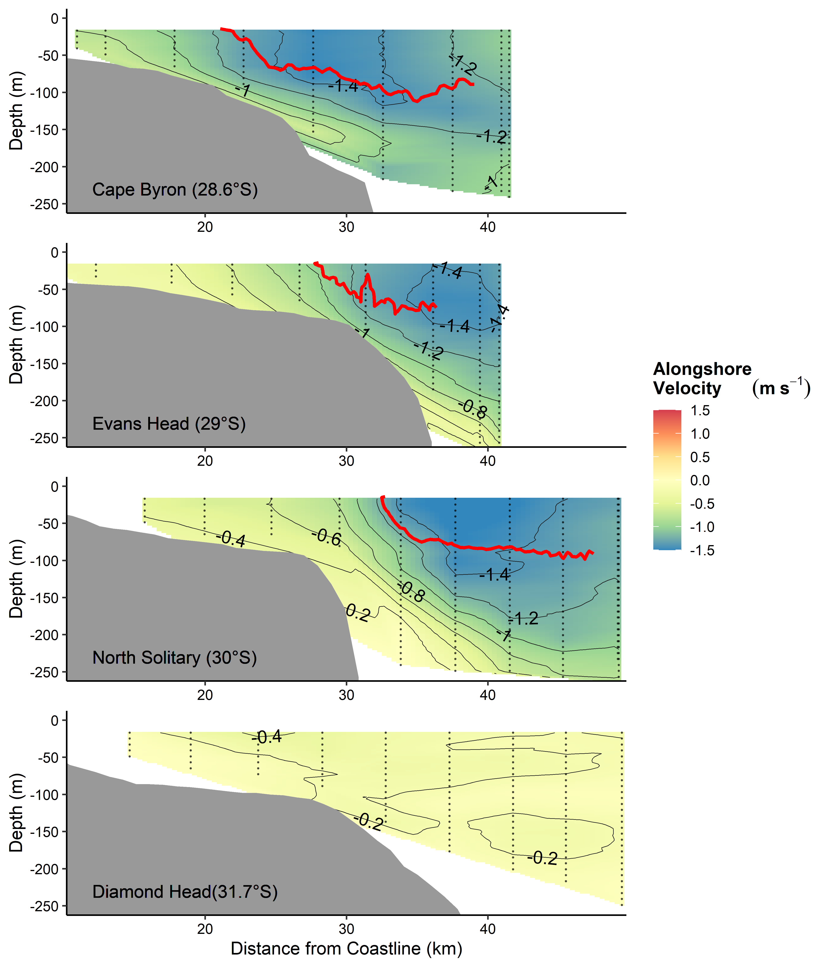

Figure 2 Alongshore velocity across the four cross shelf transects (Figure 1). Transects were conducted with an Acoustic Doppler Current Profiler during a CTD Transect. Grey lines join areas of equal velocity. The red line shows the 21°C isotherm based on the Bunyip transect. Note there was no 21°C isotherm for Diamond Head.

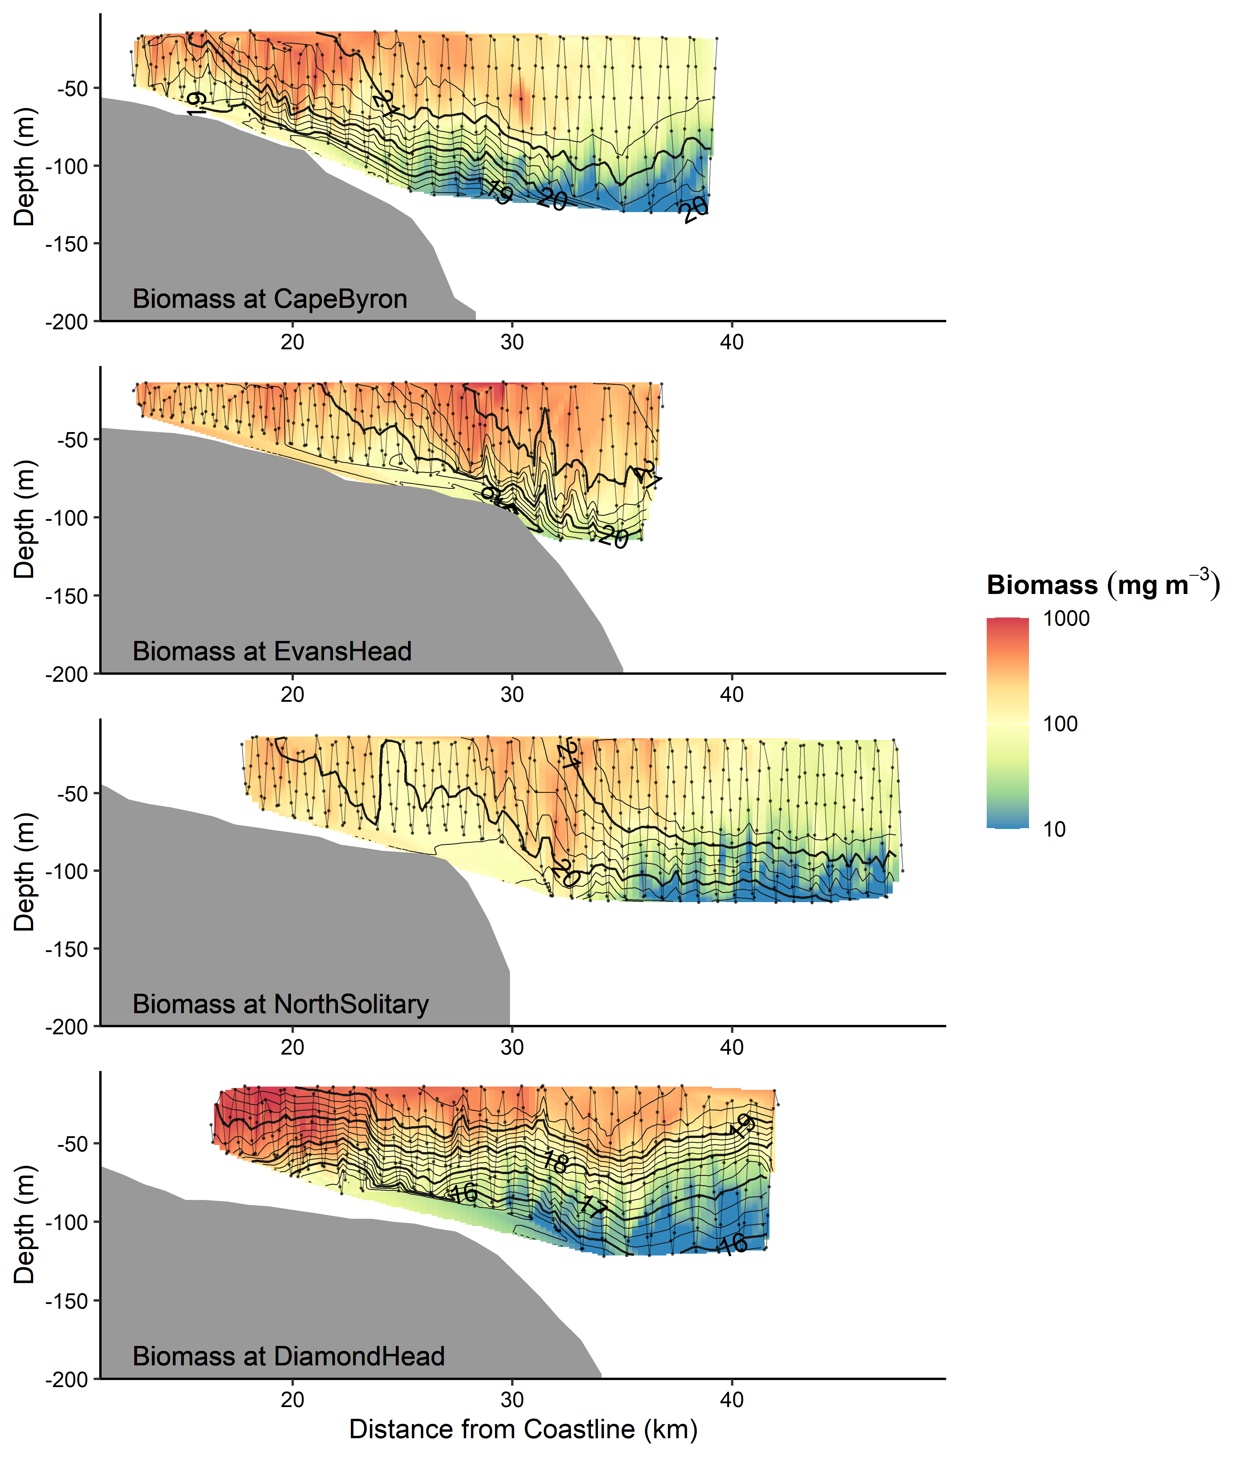

**Figure 3** Zooplankton biomass (mg m-3) distributions from the four cross shelf transects (Figure 1). Transe**c**ts were conducted form inshore to offshore with an undulating towed body with the path shown by the grey line with midpoints of each sample shown as dots. Temperature (°C) isotherms are shown in black. Note the log transformed colour scale.

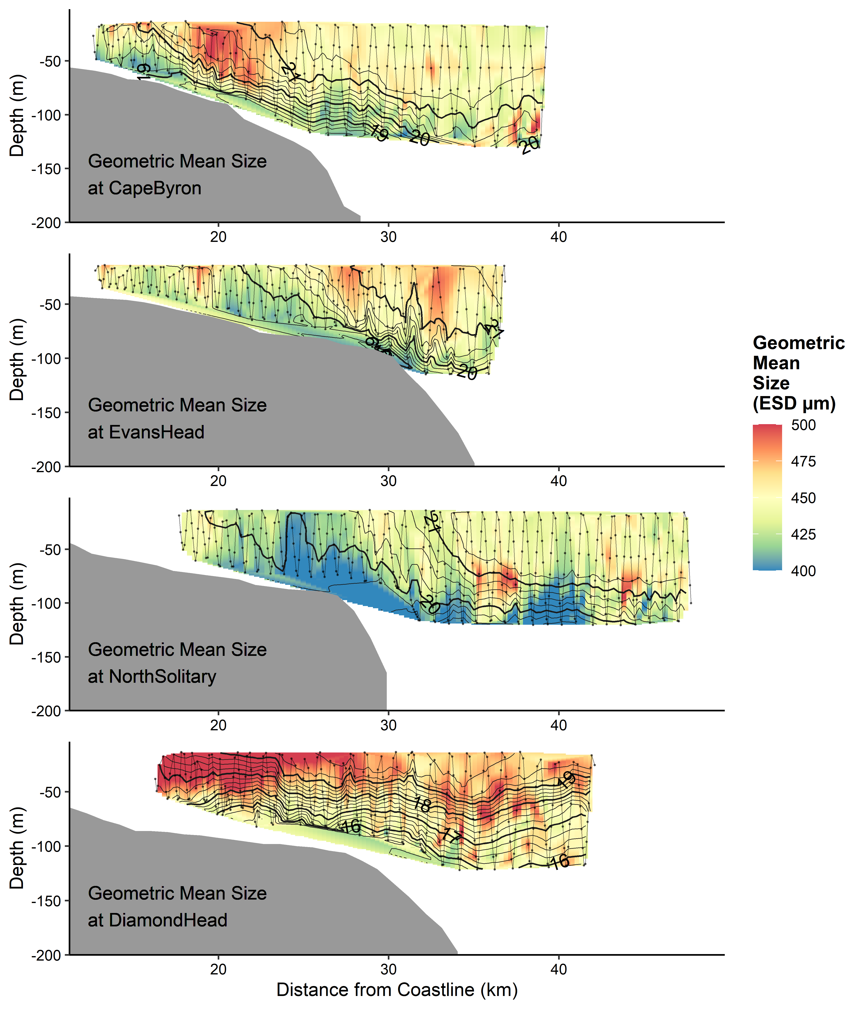

**Figure 4** Geometric Mean Size (µm equivalent spherical diameter) of zooplankton from the four cross shelf transects (Figure 1). Transects were conducted form inshore to offshore with an undulating towed body with the path shown by the grey line with midpoints of each sample shown as dots. Temperature (° C) isotherms are shown in black.

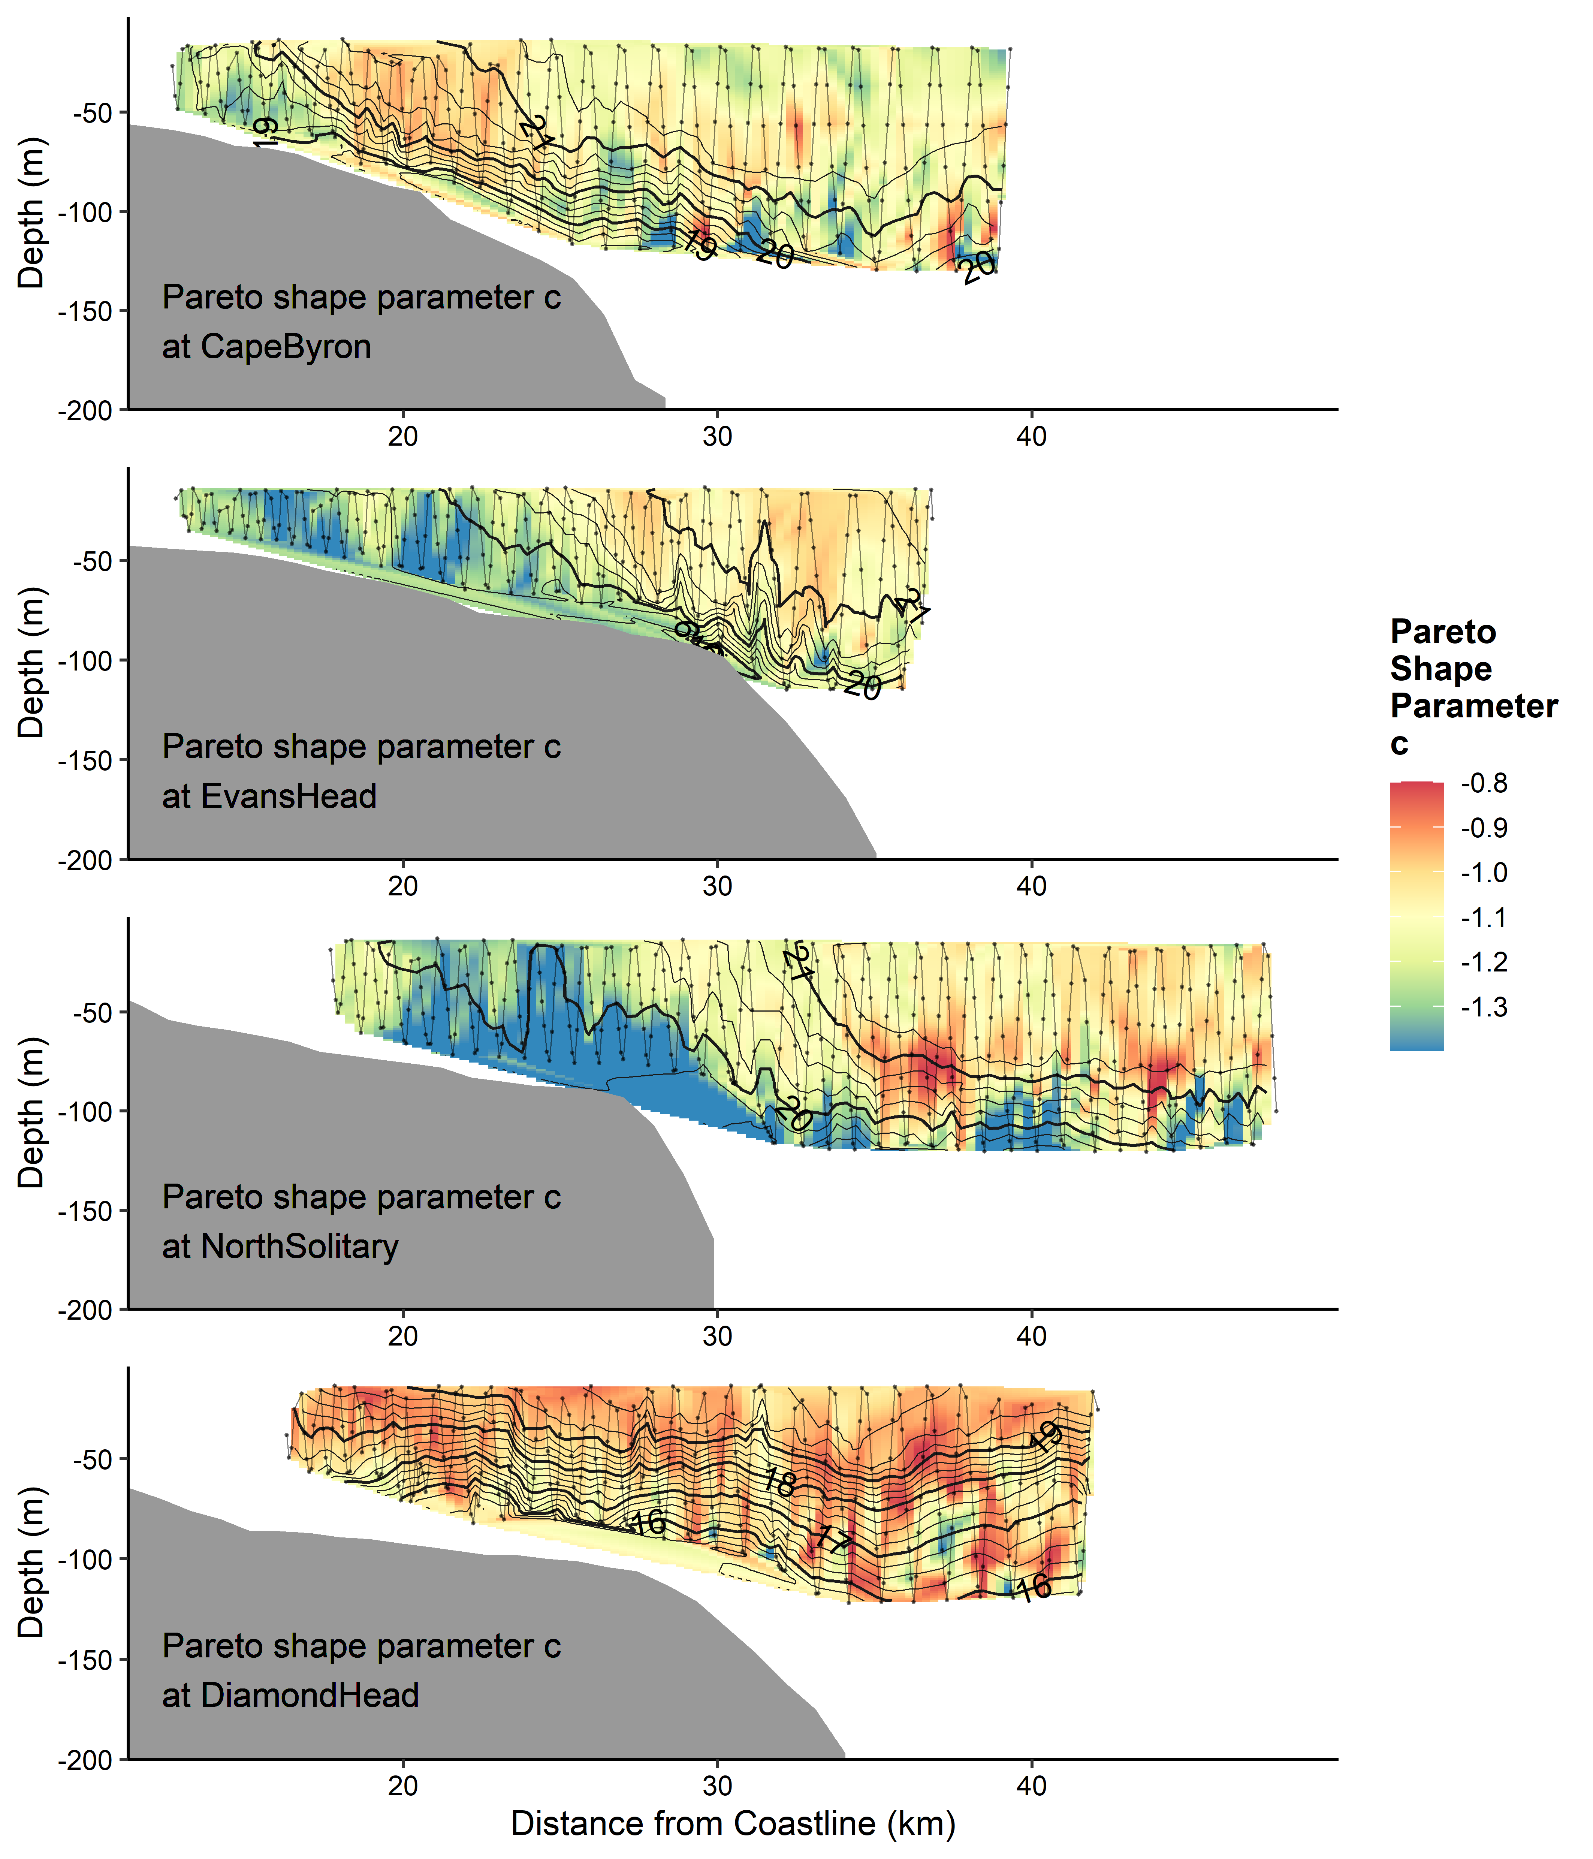

**Figure 5** Interpolations of the shape parameter *c* from the Pareto distribution of zooplankton size from the four cross shelf transects (Figure 1). This is an estimate of the normalised biomass size spectrum slope. Transects were conducted form inshore to offshore with an undulating towed body with the path shown by the grey line with midpoints of each sample shown as dots. Temperature (° C) isotherms are shown in black.



**Figure 6** Seasonal changes in mean alongshore velocity at the Cape Byron (28.6° S), Evans Head (29° S), North Solitary Island (30° S) and Diamond Head (31.8° S) based upon 10 years of satellite altimetry data (2004 – 2013). Velocity data was downloaded for the eastern edge of each transect (Table 1) from the IMOS Data Portal (<http://imos.aodn.org.au/imos/>). The EAC separates from the coastline varies between approximately 28° S and 32° S (Cetina-Heredia *et al.*, 2014).

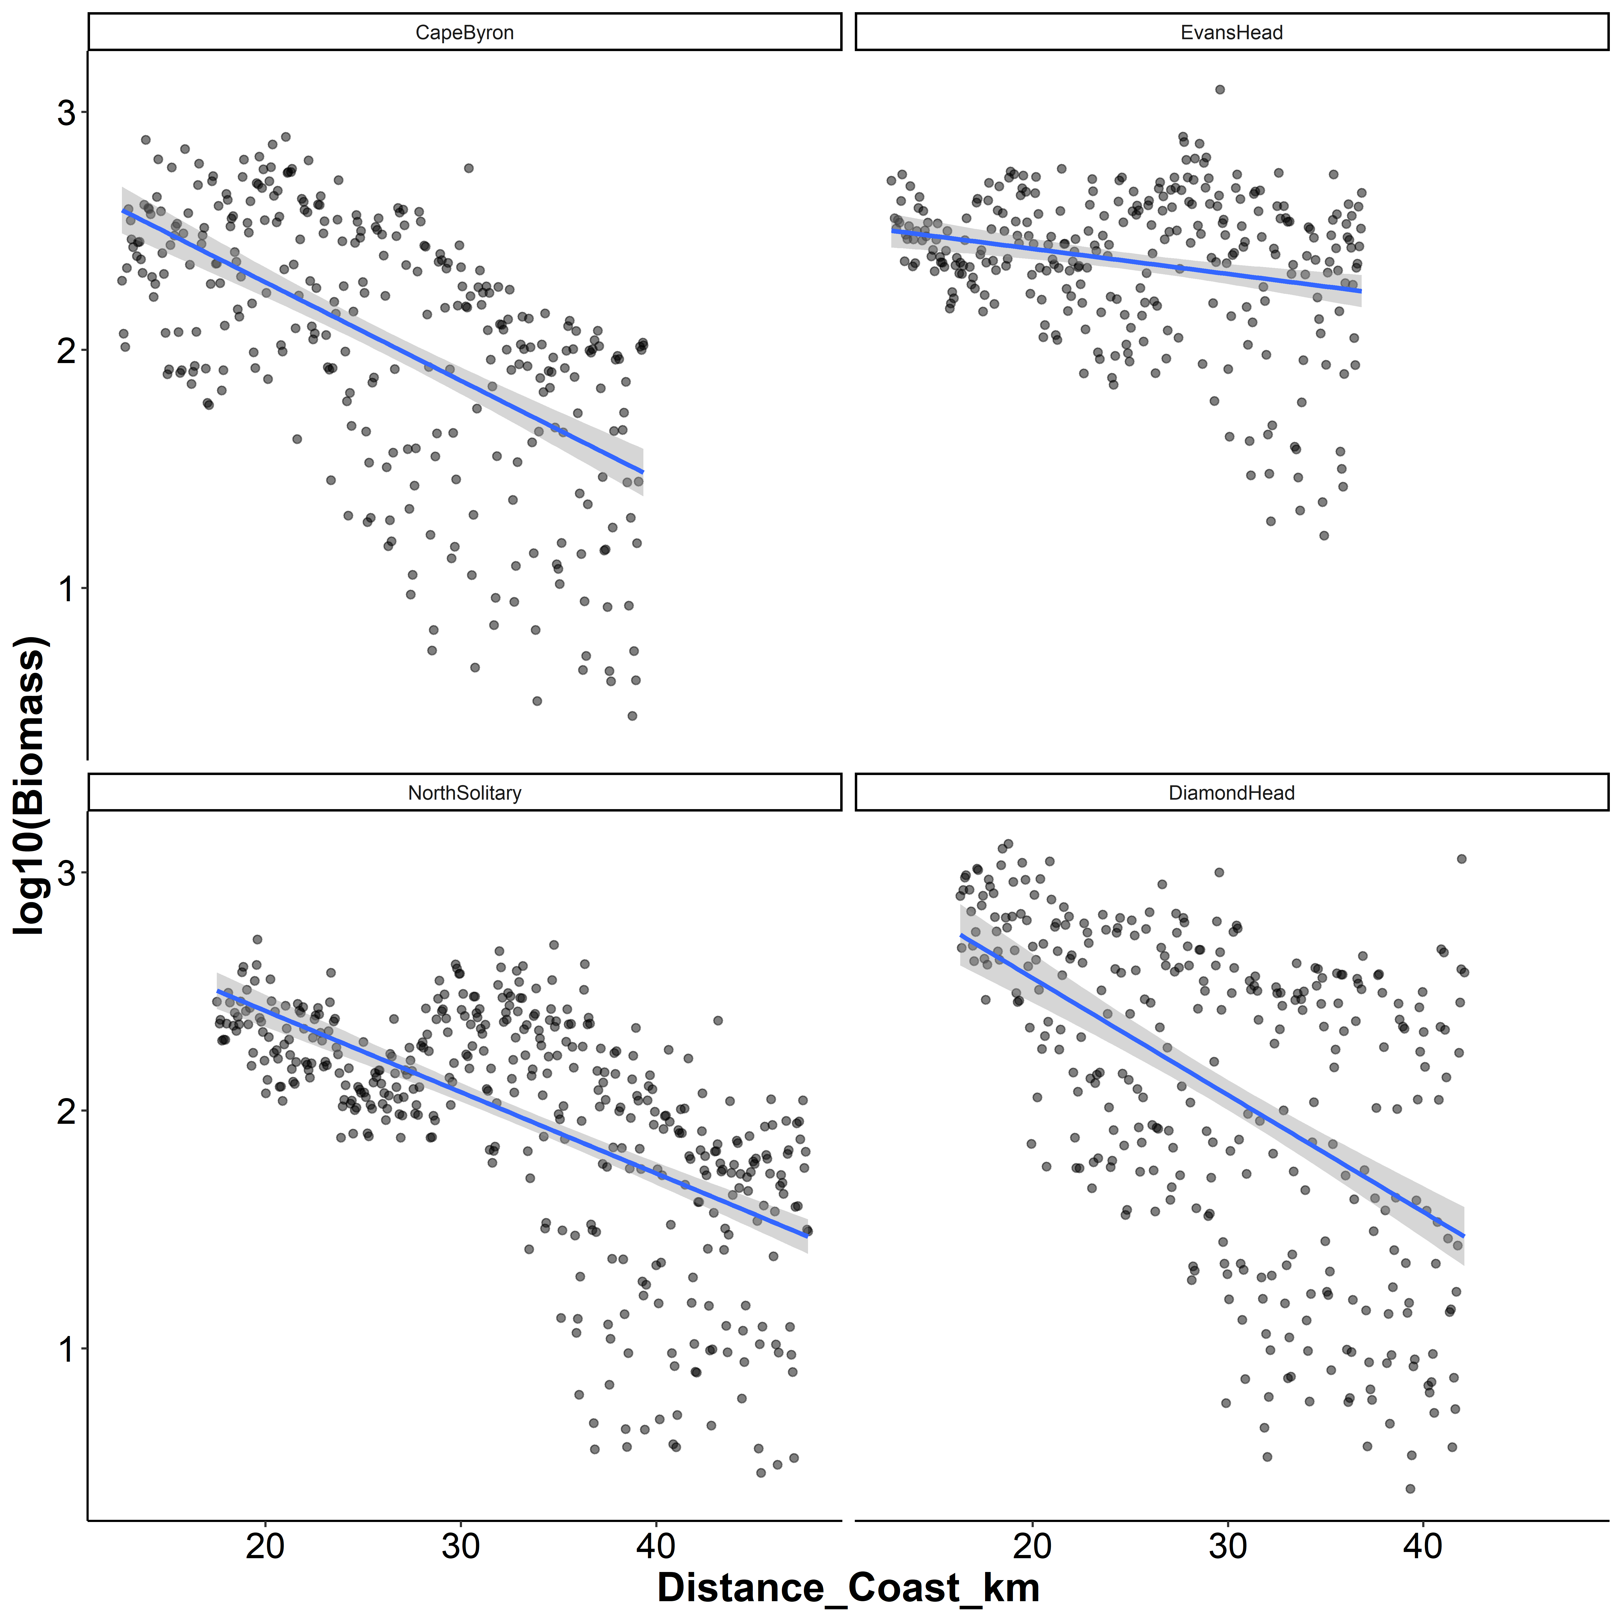

**Figure 7** Log10(Biomass) by distance from the coast for the four transects. Each dot represents a 6 s integration from the OPC mounted on the undulating towed body. Blue lines represent the linear trend line with the 95% confidence intervals shown in grey.

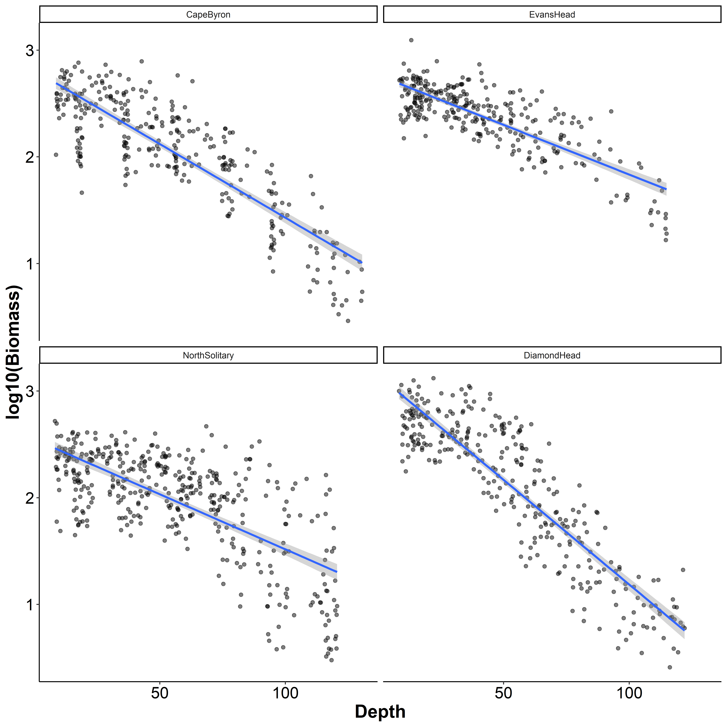

**Figure 8** Log10(Biomass) by sample depth for the four transects. Each dot represents a 6 s integration from the OPC mounted on the undulating towed body. Blue lines represent the linear trend line with the 95% confidence intervals shown in grey.

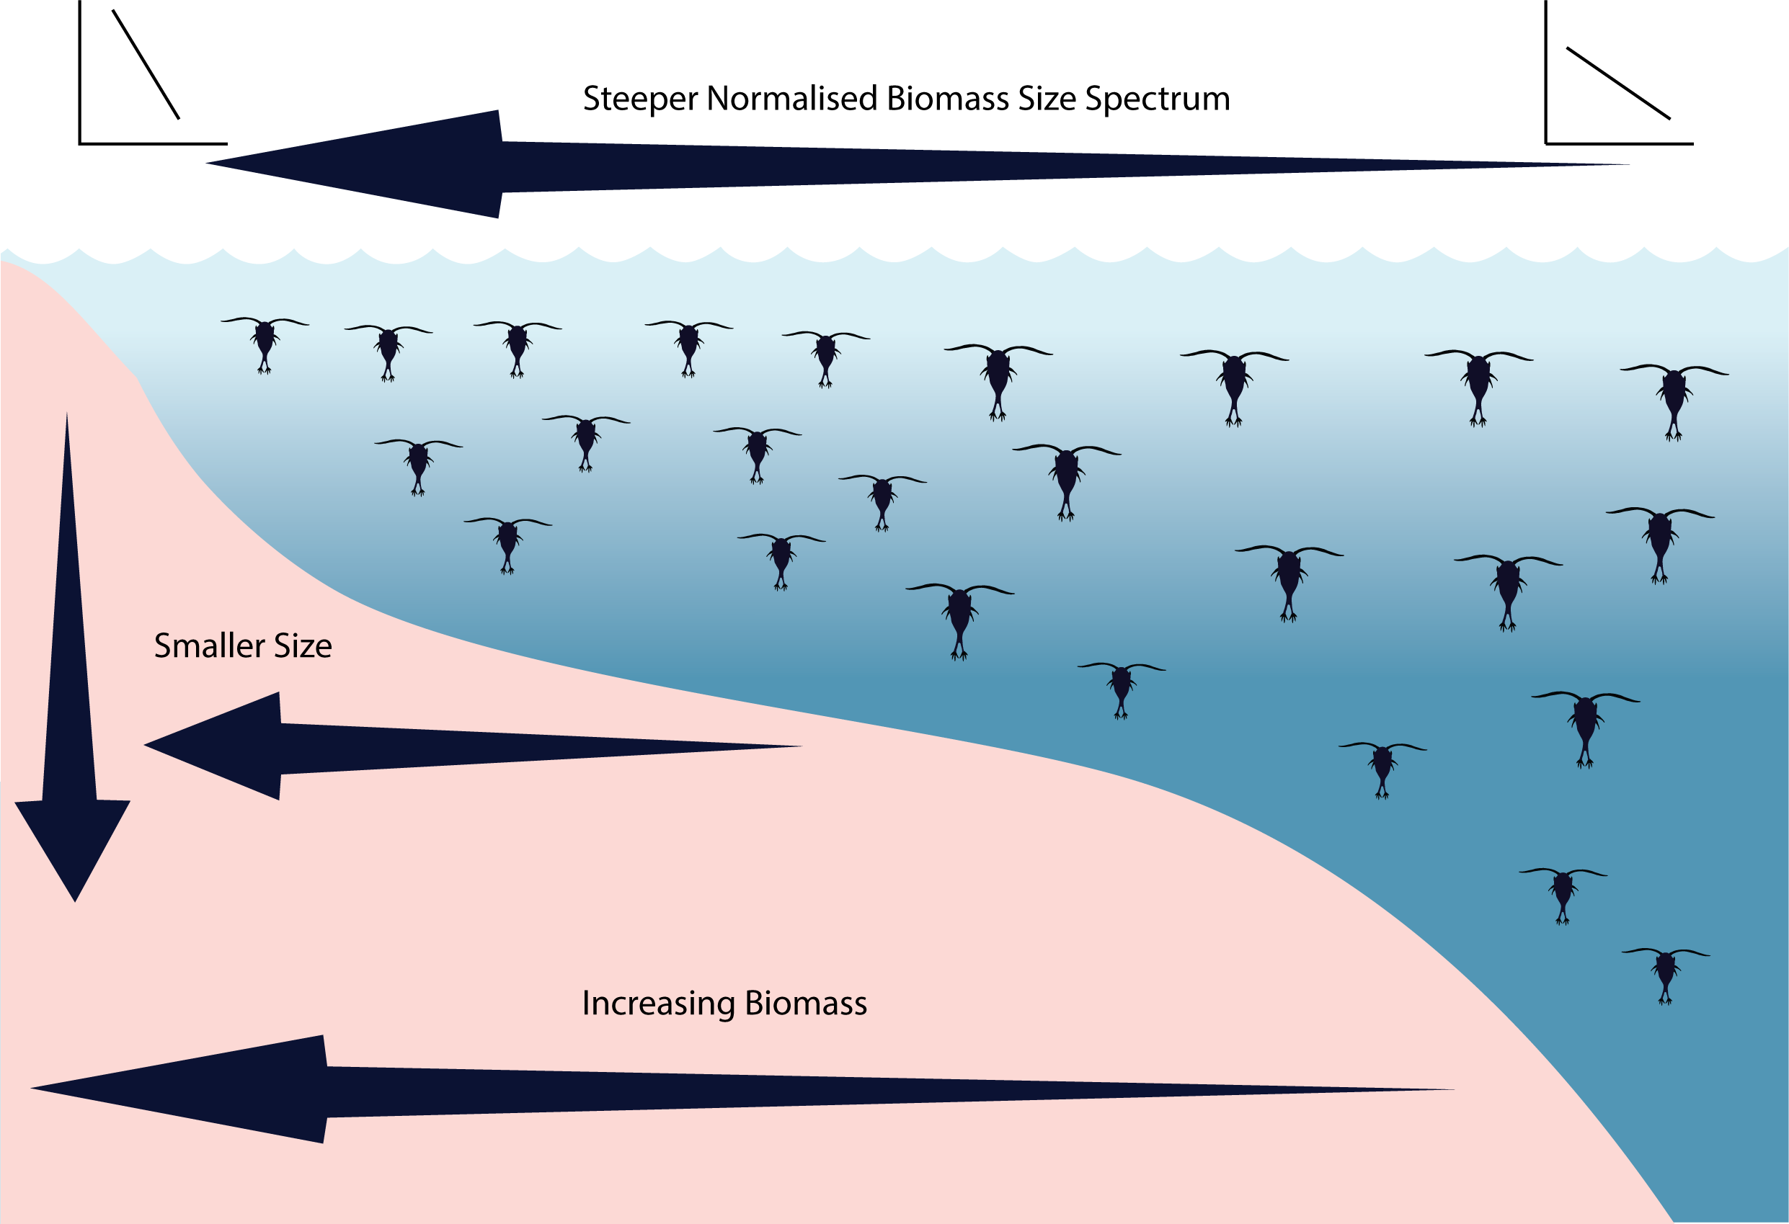

**Figure 9** Idealised concept diagram of the zooplankton community and how it changes over a continental shelf and with depth. Note all zooplankton are represented by copepods in this image.

**Supplementary Material**

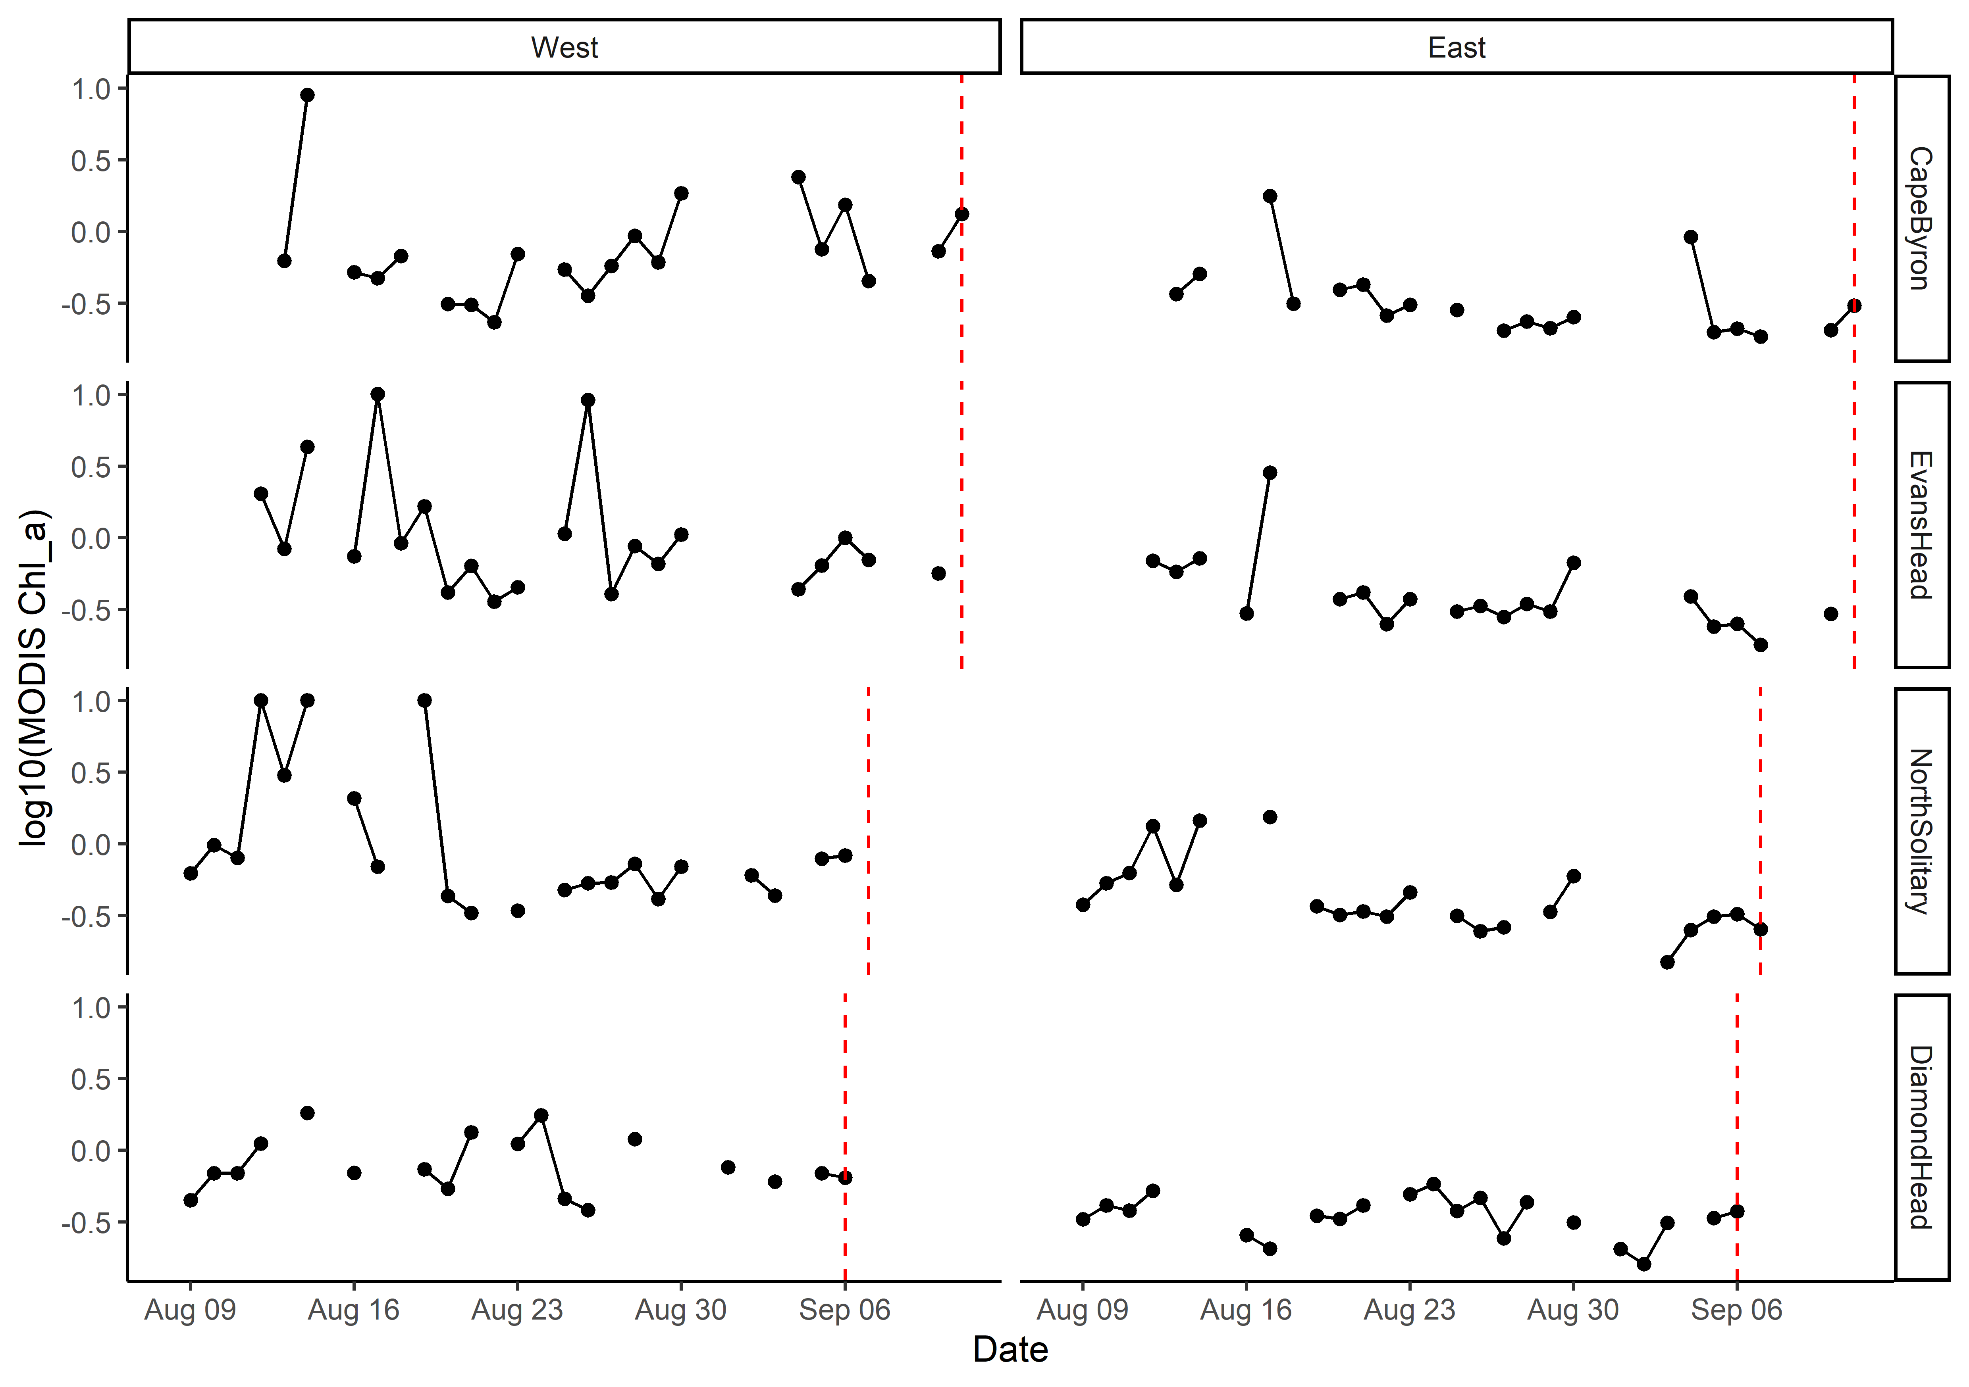

Figure S1. Satellite observed chlorophyll *a* in the month prior to each transect based upon a 5 x 5 km region around the western and eastern edges of each transect. Gaps are due to days with no data due to cloud cover. The vertical red line shows the day each transect was sampled.

To do – Tidy up plot labels etc.

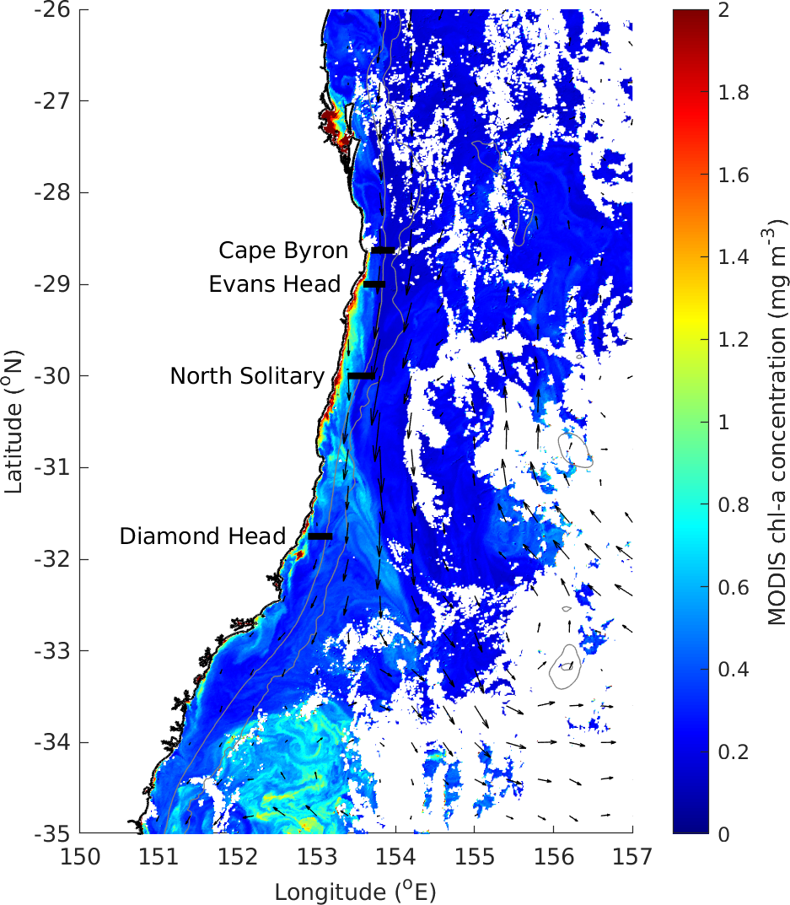

Figure S2 MODIS Chlorophyll *a* in the study region on the 6th and 10th of September showing no big upwelling at the Diamond Head site.

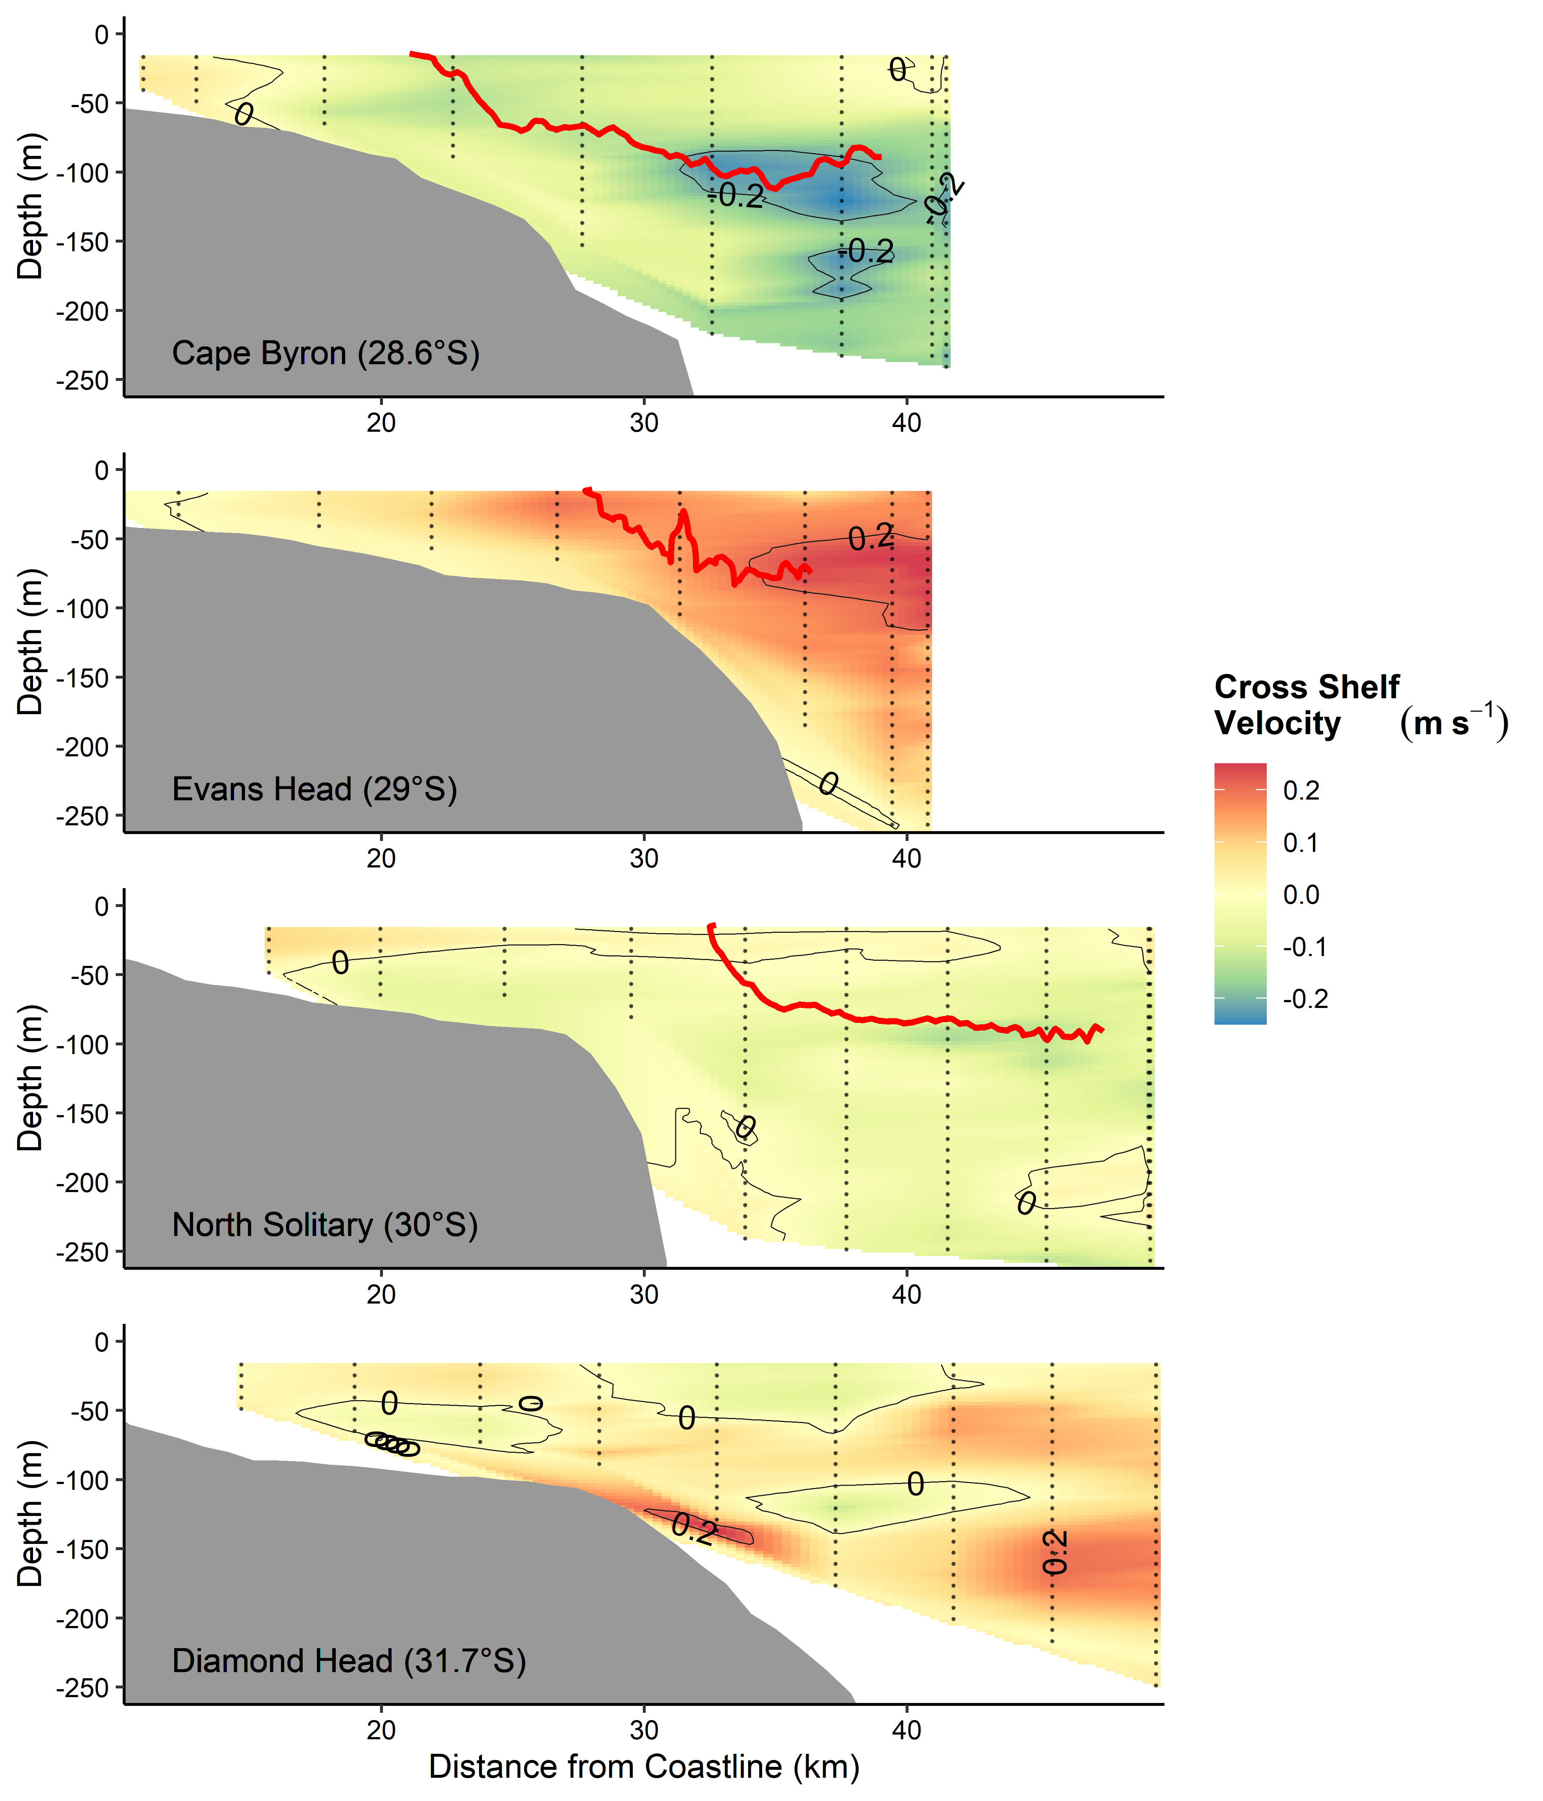

Figure SX – Cross shelf velocity. Red line is 21°C isotherm.

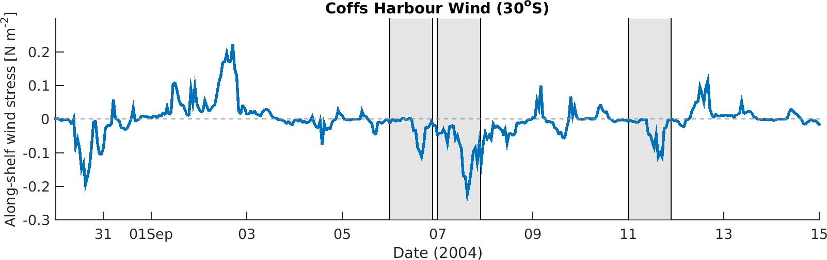

Figure SX Time-series of along-shelf (northward) wind stress component calculated from the observed wind at Coffs Harbour (30° S, local time). Negative values show upwelling favourable winds.